COMPUTER NETWORKS ASSIGNMENT
(WIRESHARK)

Name: Shubham Rawat
Roll No. : 26
Subject: Computer Networks
Semester: First
Batch: 2020 - 2022

1. Find 3 different protocols that appear in the protocol list.

a. DNS

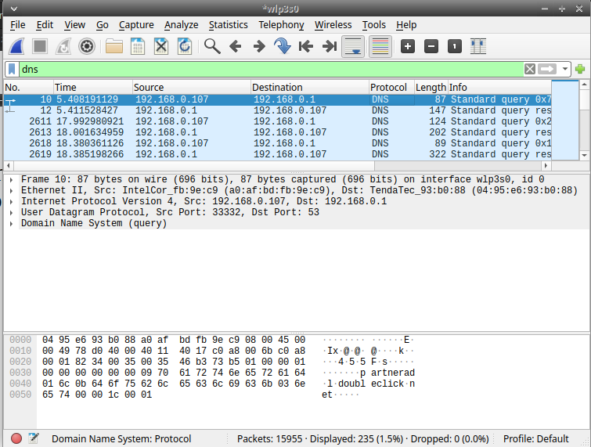

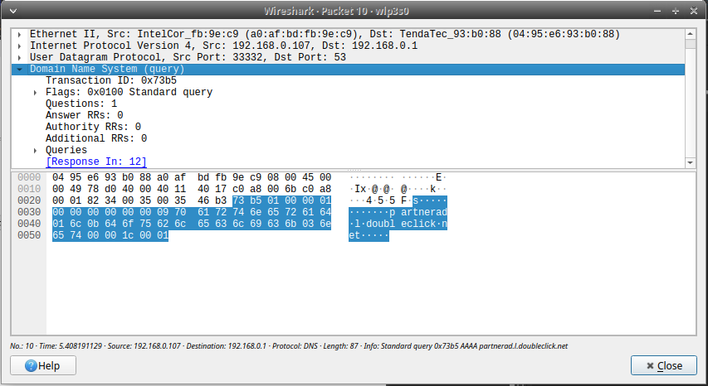

b. TCP
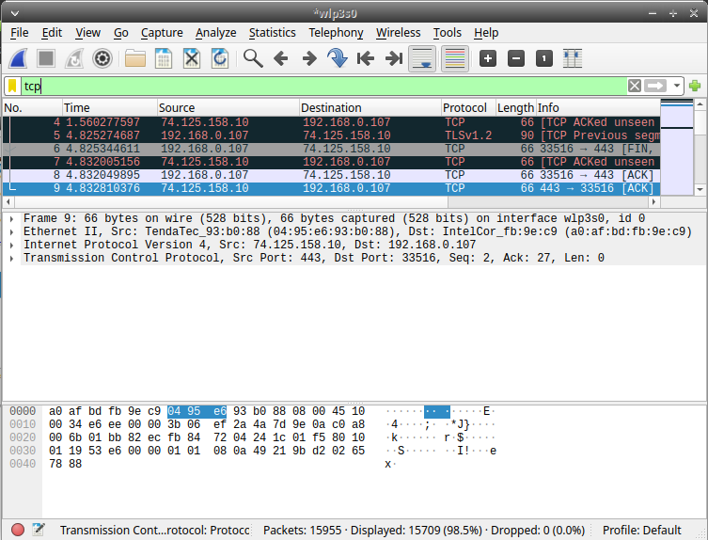
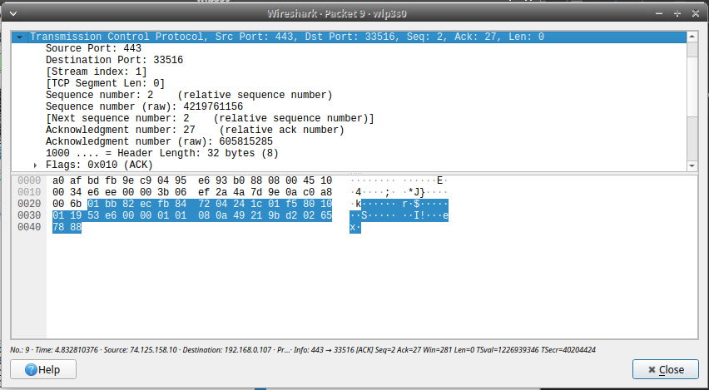
c. ARP
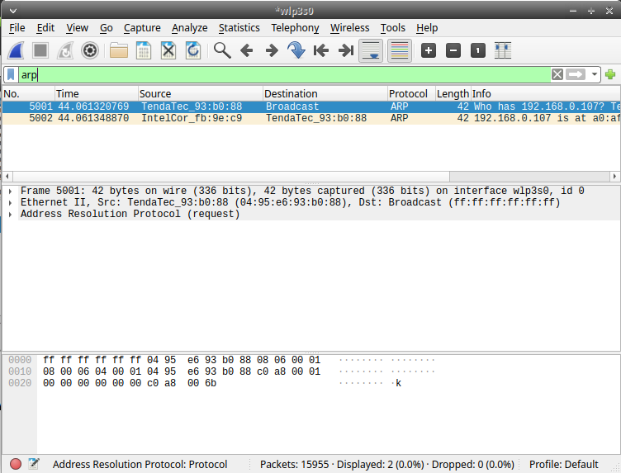
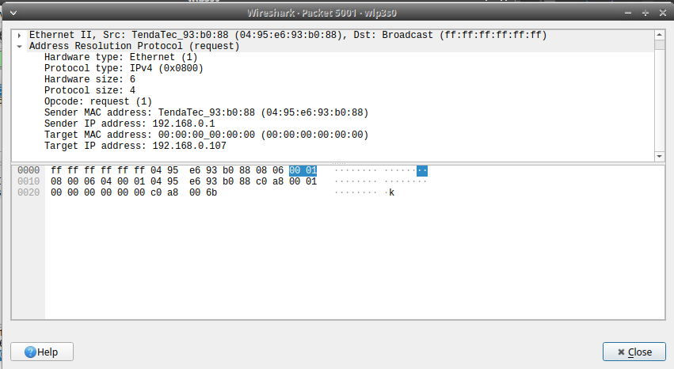
2. Find the internet address of your computer and your server. Identity the internet address
of any one homepage captured.

IP address of the computer - 192.168.0.107
IP of google home page - 172.217.167.14
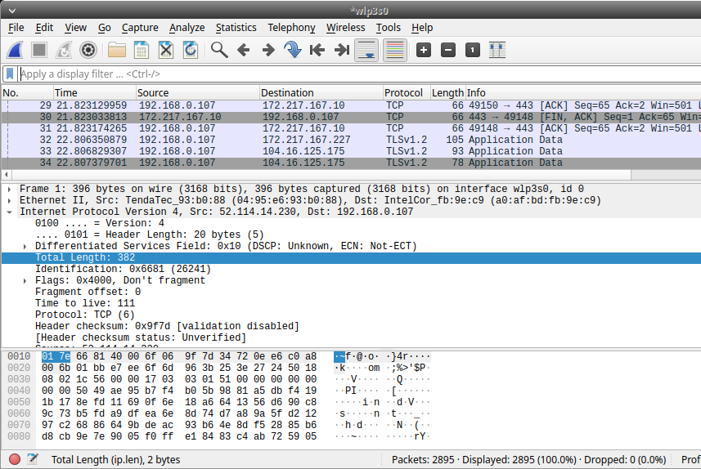

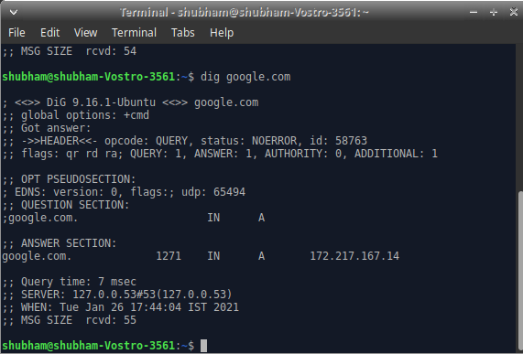

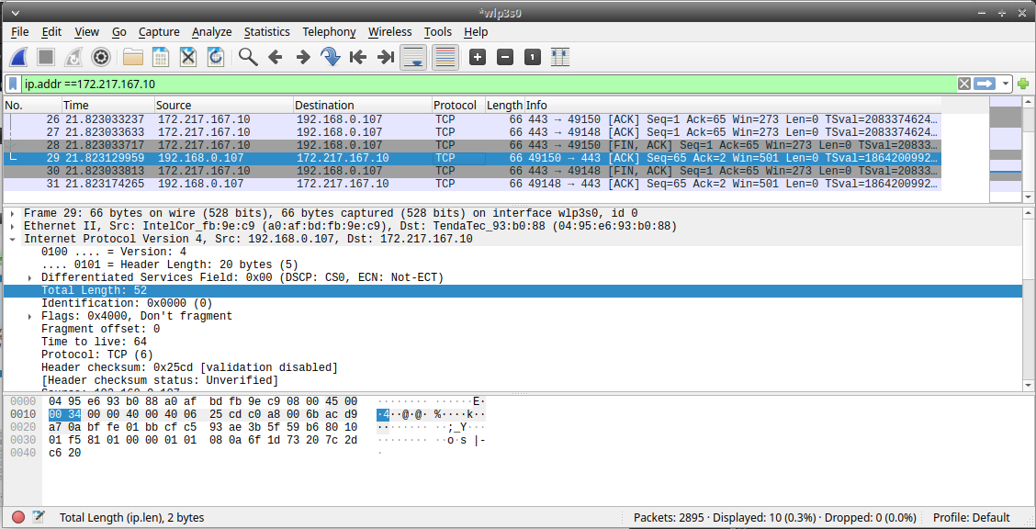

3. Find and capture the protocol hierarchy for a UDP/ SSDP segment.

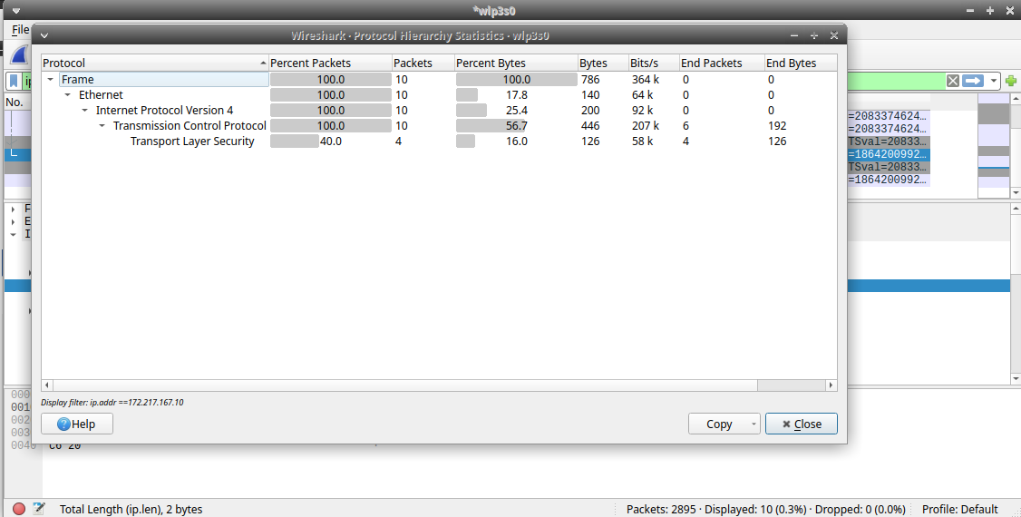
"Protocol","Percent Packets","Packets","Percent Bytes","Bytes","Bits/s","End Packets","End Bytes","End Bits/s"
"Frame",100,10,100,786,364833.0827500346,0,0,0
"Ethernet",100,10,17.8117048346056,140,64982.99183842855,0,0,0
"Internet Protocol Version 4",100,10,25.44529262086514,200,92832.84548346935,0,0,0
"Transmission Control Protocol",100,10,56.74300254452926,446,207017.24542813667,6,192,89119.53166413058
"Transport Layer Security",40,4,16.03053435114504,126,58484.6926545857,4,126,58484.6926545857

4. Apply display filter to show all TCP segments on an interface. Also state what does black
coloured TCP Segments indicate?
a.
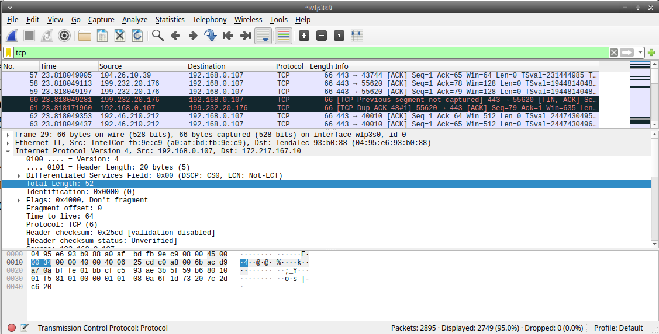

b. Black TCP segment indicate what

The packet highlight in black identifies that the TCP packet with problem – for example ,they could have been delivered out of the order.

5. Identify the time difference between a set of DNS query and its DNS response. Show it
with the help of an example

DNS query to ISP time 91.895391378
DNS response from ISP time 91.916807185
